Assignment (4.2)

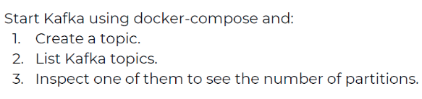
Solution

- We use docker compose to run our containers.

- We have created topics with name event1 and event2 in kafka with partitions 3 and 5.
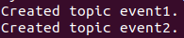

- Then we list the topics.


- Now we can see the partitions by using describe.
